7. Breadth First Search (BFS)
Aim
To write a Python program to implement Breadth First Search (BFS).
Procedure
- Start from the source node.
- Add the source node to a queue.
- Remove a node from the front of the queue.
- Visit its unvisited adjacent nodes.
- Add them to the queue.
- Repeat until all required nodes are visited.
Program
from collections import dequegraph = { 'A': ['B', 'C'], 'B': ['D', 'E'], 'C': ['F'], 'D': [], 'E': [], 'F': []}visited = set()queue = deque(['A'])while queue: node = queue.popleft() if node not in visited: print(node, end=" ") visited.add(node) queue.extend(graph[node])
Output:
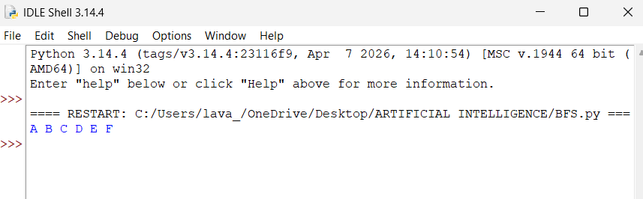
Result
Thus, BFS was successfully implemented and the nodes were visited level by level.

